Pupil premium strategy statement

This statement details our school’s use of pupil premium funding to help improve the attainment of our disadvantaged pupils.

It outlines our pupil premium strategy, how we intend to spend the funding in this academic year and the effect that last year’s spending of pupil premium had within our school.

School overview
Detail | Data
School name | Palace Fields Primary School
Number of pupils in school | 106
Proportion (%) of pupil premium eligible pupils | 48%
Academic year/years that our current pupil premium strategy plan covers. | 2026-2029
Date this statement was published | October 2026
Date on which it will be reviewed | 01.09.2027 and yearly thereafter.
Pupil premium lead | Genna Hitchin - Headteacher
Governor / Trustee lead | Laura McGunigle – Chair of Governors
Funding overview
Detail | Amount
Pupil premium funding allocation this academic year | £82,150
Pupil premium funding carried forward from previous years (enter £0 if not applicable) | 0
Total budget for this academic year  If your school is an academy in a trust that pools this funding, state the amount available to your school this academic year | £82,150

Part A: Pupil premium strategy plan

Statement of intent
At Palace Fields Primary School we have identified the contextual considerations for our pupils. Our overall aim is to provide the highest quality of education for our pupils removing barriers to learning and closing the gap between disadvantaged and non-disadvantaged pupils in regards to academic achievements and through addressing the multiple vulnerabilities through pastoral support and our Thrive approach. Children within our school enter with lower language skills and we seek to close the gap between PP and non PPG children in regards to language development and writing achievements. In place we use diagnostic assessment to identify areas that require targeting throughout all key stages and tailor intervention to support this. In place we have WELCOMM in the Early Years, precision teaching by trained teaching assistants, Fresh Start and phonics interventions. All of these approaches have been successful at improving our children’s language skills and this remains one of our key principles.

Challenges

This details the key challenges to achievement that we have identified among our disadvantaged pupils.
Challenge number | Detail of challenge
1 | Phonic and language skills in Reception/KS1 are lower for pupils eligible for PP than for other pupils, and even more so for pupils who are PP/SEND. This slows reading and writing progress in subsequent years. Our aim is for all children to become fluent readers.
2 | Vocabulary and oracy – A vocabulary gap and weaker oral language can reduce access to subject texts, classroom discussion and extended writing across the curriculum, impacting outcomes and confidence beyond school.
3 | Behaviour, engagement and belonging: A group of pupils eligible for PP display having difficulties in Social and Emotional aspects of their learning including low confidence, low self esteem and anxiety. This leads to this group of pupils underachieving and receiving repeat suspensions.
4 | Attendance rates for pupils eligible for PP are in line with national average for PP however, they are lower than non PP students and there are more persistent absentees. This reduces their school hours and causes them to fall behind on average.
5 | Foundational skills – Due to children entering at lower starting points, the gap can widen between peers, this is notable in some subject areas due to poorer foundational skills.

Intended outcomes
This explains the outcomes we are aiming for by the end of our current strategy plan, and how we will measure whether they have been achieved.
Intended outcome | Success criteria
Disadvantaged pupils will achieve in line with their peers for reading and maths at both key stages. | - Children eligible for PP will show an increase in scaled scores recorded on FFT  - There will be an increased percentage of children eligible for PP reaching Exp+ at the end of the academic year.  - Gap between PP and on-PP attainment will decrease.
Disadvantaged pupils, in particular males, improve their Mental Health and Wellbeing to increase a sense of belonging leading to 0 repeat suspensions. | - Children’s mental health will improve and they will be able to access learning and also rebuild relationships with peers and staff  - Children’s academic achievements will increase as well as their Thrive assessment scores when compared with previous years.  - Suspensions for male students in receipt of PP will decline and female students will remain at 0.
Disadvantaged pupils will develop improved phonic and language skills leading to no gap between groups of children in year 1 phonics screening. | - Close the gap in Reading ability between PP and NPP children  - Improve language and vocabulary which will then support writing  - We aim to close the phonics gaps when entering KS1 and therefore achieve national average on the phonics screening check.
Disadvantaged pupils attendance will be in line with non disadvantaged pupils and continue to surpass national average. | - Attendance and punctuality rates will continue to be within the national expectation.  - The gap in attendance rates between children eligible for PP and non PPG will close in comparison with last year  - There will be reduction in persistent absence when compared with the previous year  - Case studies will reflect intervention and positive impact
Improved oracy skills for pupils, creating confident, polite individuals who can access the curriculum. | - Children will report increased confidence levels when speaking or performing outside of their peer group  - Oracy curriculum will be mapped and introduced in 2026.  - Pupil voice reflects positive views of transition and lunchtimes  - Pupils will develop their cultural capital including but not exclusive to table manners and relationships with peers  - Case studies will reflect intervention and positive impact

Activity in this academic year
This details how we intend to spend our pupil premium this academic year to address the challenges listed above.

Teaching (for example, CPD, recruitment and retention)
Budgeted cost: £ 25,634
Activity/Cost | Evidence that supports this approach | Challenge number(s) addressed
Grammarsaurus scheme which will compliment the Ready, Steady Write scheme that we previously introduced. | - Grammarsaurus  - In maths, place value is recognised as the building block on which successful mathematicians are made. Without a secure grasp of it, children often struggle to make sense of other concepts including addition, subtraction, multiplication and division. Because of its importance, place value is taught as the very first unit in each year group and revisited regularly throughout the curriculum. In a similar way, punctuation and grammar are the place value of writing. They are the building blocks of successful writers. Without a secure grasp of them, children often struggle with sentence structure, making it much harder for them to produce cohesive stories, letters and reports that readers can understand and enjoy. To reflect its importance, the Place Value of Punctuation and Grammar (PVPG) will be the very first unit taught in Years 2 - 6 and will be revisited regularly across the curriculum. In Year 1, PVPG will be introduced once children have a secure grasp of letter formation and phonics.  - Ready Steady Write (new and improved Read to Write) is comprehensive and evidence-based. It provides a sequenced, ambitious curriculum, that places quality literature at its core. (The) units have been carefully mapped out to match the entire statutory curriculum for writing. https://www.literacycounts.co.uk/ready-steady-write  - The impact of mastery learning approaches is an additional five months progress, on average, over the course of a year.  - Mastery learning also appears to be particularly effective when pupils are given opportunities to work in groups or teams and take responsibility for supporting each other’s progress.  (Education Endowment Foundation) | 1,2
Read, Write Inc including subscription, resources, leadership support, development days and CPD online training | The independent evaluators found that children in schools who were offered Read Write Inc. Phonics made, on average, one month’s additional progress in reading compared with those in the control group. (Education Endowment Foundation)  The evaluators found some evidence that pupils eligible for free school meals (FSM) responded particularly well to Read Write Inc. Phonics and made, on average, three months more progress than pupils who were not offered the programme.  ‘…professional development makes a significant difference to student attainment… the effect size of professional development was 0.09 with a 95 per cent confidence interval of 0.06 to 0.13… the effect of professional development appears to be equivalent to having a teacher in the classroom with over a decade’s experience.’ (Education Policy Institute and Ambition Institute)  ‘Spending on improving teaching might include professional development, training and support for early career teachers… Ensuring an effective teacher is in front of every class, and that every teacher is supported to keep improving, is the key ingredient of a successful school and should rightly be the top priority for Pupil Premium spending’ (EEF Pupil Premium Guide) | 1,2
Additional staffing to facilitate smaller class sizes for phonics teaching, to support targeted support | ‘Good teaching is the most important lever schools have to improve outcomes for disadvantaged pupils’ (EEF Guide to Pupil Premium)  ‘The effect of having a very effective teacher as opposed to an average teacher is the same as the effect of reducing class size by ten students in Year 5 (ages 9-10) and thirteen or more students in Year 6 (ages 10-11). The effects of high-quality teaching are especially large for pupils from disadvantaged backgrounds, who gain an extra year’s worth of learning under very effective teachers compared to poorly performing teachers’. (The Sutton Trust) | 1,2
Maths no problem scheme  Times table scheme to support the teaching of times tables across KS2. | The Maths — No Problem! Primary Series was assessed by the DfE’s expert panel, which judged that it met the core criteria for a high-quality textbook to support teaching for mastery. As a result, the MNP Primary Series are recommended textbooks for schools on the mastery programme.  ‘The key principle of mastery is high expectations that all pupils will achieve… teachers are beginning to see a way forward in making a difference for teaching and learning; in particular a deep and sustainable learning for their pupils’ (NCETM)  Countries at the top of the table for attainment in mathematics education employ a mastery approach to teaching mathematics. Teachers in these countries do not differentiate their maths teaching by restricting the mathematics that ‘weaker’ children experience, whilst encouraging ‘able’ children to ‘get ahead’ through extension tasks (NCETM)

Targeted academic support (for example, tutoring, one-to-one support structured interventions)
Budgeted cost: £ 36,947
Activity | Evidence that supports this approach | Challenge number(s) addressed
Fast track tutoring for phonics and Verbo used for speech and language support. | Phonics has a positive impact overall (+5 months) with very extensive evidence and is an important component in the development of early reading skills, particularly for children from disadvantaged backgrounds.  The teaching of phonics should be explicit and systematic to support children in making connections between the sound patterns they hear in words and the way that these words are written.  Phonics improves the accuracy of the child’s reading but not necessarily their comprehension. It is important that children are successful in making progress in all aspects of reading including comprehension, the development of vocabulary and spelling, which should also be taught explicitly.  The average impact of the adoption of phonics approaches is about an additional five months’ progress over the course of a year.  Phonics approaches have been consistently found to be effective in supporting younger pupils to master the basics of reading, with an average impact of an additional five months’ progress. Research suggests that phonics is particularly beneficial for younger learners (4−7 year olds) as they begin to read. Teaching phonics is more effective on average than other approaches to early reading (such as whole language or alphabetic approaches), though it should be emphasised that effective phonics techniques are usually embedded in a rich literacy environment for early readers and are only one part of a successful literacy strategy.  (Education Endowment Foundation) | 1,2
Teaching assistant to teach small Maths interventions  Focus on closing the gap in writing and Maths for PP and NPP. | ‘Good teaching is the most important lever schools have to improve outcomes for disadvantaged pupils’ (EEF Guide to Pupil Premium)  ‘The effect of having a very effective teacher as opposed to an average teacher is the same as the effect of reducing class size by ten students in Year 5 (ages 9-10) and thirteen or more students in Year 6 (ages 10-11). The effects of high-quality teaching are especially large for pupils from disadvantaged backgrounds, who gain an extra year’s worth of learning under very effective teachers compared to poorly performing teachers’. (The Sutton Trust)  ‘Evidence indicates that one to one tuition can be effective, delivering approximately five additional months’ progress on average’  ‘Overall, evidence shows that small group tuition is effective… Once group size increases above six or seven there is a noticeable reduction in effectiveness’ (EEF Toolkit)
Precision Teaching (Intervention) 1:1 | SAFMEDS has a growing evidence-base, with a number of controlled studies demonstrating positive outcomes. The School of Psychology at Bangor University has been piloting SAFMEDS with schools in North Wales over recent years, with encouraging findings indicating the programme helps children improve their basic mathematics skills. These studies also show that the retention of these skills is good.  Teaching assistants can provide a large positive impact on learner outcomes.  The high average impact hides a large variation between the different approaches to teaching assistant deployment. Targeted deployment, where teaching assistants are trained to deliver an intervention to small groups or individuals has a higher impact, whereas deployment of teaching assistants in everyday classroom environments has not been shown to have a positive impact on learner outcomes. At Palace Fields Primary School teaching assistants are trained in the precision teach approach by Educational Psychologists.  Evidence indicates that one to one tuition can be effective, providing approximately five additional months’ progress on average.  Short, regular sessions (about 30 minutes, three to five times a week) over a set period of time (up to ten weeks) appear to result in optimum impact. Evidence also suggests tuition should be additional to, but explicitly linked with, normal teaching, and that teachers should monitor progress to ensure the tutoring is beneficial.  On average, one to one tuition is very effective at improving pupil outcomes. One to one tuition might be an effective strategy for providing targeted support for pupils that are identified as having low prior attainment or are struggling in particular areas.  Tuition is more likely to make an impact if it is additional to and explicitly linked with normal lessons.  For one to one tuition led by teaching assistants, interventions are likely to be particularly beneficial when the teaching assistants are experienced, well-trained and supported – for example, delivering a structured intervention. As above teaching assistants are trained in this approach by Educational Psycyhologists.  (Education Endowment Foundation) | 1,2
Fresh Start Intervention for pupils | The FS pupils in the intervention group made more progress in literacy than the control group after 22 weeks. The overall effect size was +0.24 in terms of the gain between the scores in the test before the intervention (the pre-test) and the test after the intervention (the post-test). This is equivalent to approximately 3 months of additional progress in reading age. Progress was assessed as the gain in scores between a pre-test (GL Assessment’s New Group Reading Test A) and a post-test (New Group Reading Test B). The impact evaluation also suggests positive progress results for FSM-eligible pupils, and for all pupil sub-groups regardless of age, sex, first language, ethnicity, or special education need.  Reading comprehension strategies are high impact on average (+6 months). Alongside phonics it is a crucial component of early reading instruction.  It is important to identify the appropriate level of text difficulty, to provide appropriate context to practice the skills, desire to engage with the text and enough challenge to improve reading comprehension. At Palace Fields Primary School children are regularly assessed and targeted to ensure interventions are tailored and also the level of challenge is appropriate.  Last Year Fresh Start was completed with Year 6 pupils and 100% of children made expected progress from their starting points, alongside this 7/8 children within the intervention met the expected standard for reading therefore this will be continued this year.  Effective diagnosis of reading difficulties is important in identifying possible solutions, particularly for older struggling readers. Pupils can struggle with decoding words, understanding the structure of the language used, or understanding particular vocabulary, which may be subject-specific. Palace Fields Primary School uses a variety of assessments to identify specific difficulties e.g. NFER, YARC and phonics screening.  The average impact of reading comprehension strategies is an additional six months’ progress over the course of a year. Successful reading comprehension approaches allow activities to be carefully tailored to pupils’ reading capabilities, and involve activities and texts that provide an effective, but not overwhelming, challenge.  (Education Endowment Foundation) | 2

Wider strategies (for example, related to attendance, behaviour, wellbeing)
Budgeted cost: £ 17,256
Activity | Evidence that supports this approach | Challenge number(s) addressed
EWO SLA to target pupils and families who are PA | ‘There's a clear link between poor attendance and lower academic achievement… 73% of pupils who have over 95% attendance achieve 5 or more GCSEs at grades A*-C… Pupils with persistent absence are less likely to attain at school and stay in education after the age of 16 years’ (NFER)  Missing school for just a few days a year can damage pupils’ chances of gaining good GCSEs, (DfE)  Children who started missing school at the primary level find it difficult to study as they have already developed a very poor attitude to school. … the EWOs, will try to look for ways to help parents get their children to school more frequently. This is particularly helpful to parents whose children miss school due to circumstances that are out of their control rather than out of choice… Getting a good education will ensure that children will have a better chance at becoming something good in the future. (CPD Online)  Attendance figures increased from this in previous years so this will be continued | 4
  Attendance 2025-2026
  PP – 92.3%
  NPP – 95.6%
Thrive support for SEMH through employment of Family Support Worker | The cornerstone of these positive outcomes being derived from Thrive is the influence on feelings of self worth, which is bound up with the development of a sense of self and in turn a sense of reliance and trust in themselves. (Thrive)  Another important strand in this whole process is the raising of self‐esteem, and with it gaining an improved understanding of themselves as an individual. In turn this helps to build emotional resilience. Many children with interruptions suffer from low self‐esteem and low self worth, and this can often manifest itself in violent or damaging activities such as being bullied or being violent to others due to their own insecurities. Armed with a greater sense of self worth, sense of belonging and trust, the child then grows in confidence, is more motivated and is better able to engage in learning and understand their own skills and abilities and how to extend them. And of course all of these attributes then form the bedrock of the longer‐term outcomes. (Thrive)
Partial or full subsidy for students to attend residential (or other) visits, and/or access wider curriculum experiences, in order to widen pupil experiences and provide cultural capital opportunities. | ‘(Residential trips…cost prohibited many poorer pupils from taking part. Some pupils did not have the means to access this opportunity even though they would probably have benefited most from the experiences’ (LKMco Think Tank/Learning Away)  ‘The different learning environment and deeper relationships developed on residentials contributed to improved engagement with learning, including positive changes in behaviour and attendance’ (Learning Away)  ‘The most commonly reported or perceived form of impact (of residential experiences) was affective: changes in students’ confidence and self esteem; attitude changes: students felt more ‘positive’; relationship building: students formed productive peer relationships and student: staff relationships were enhanced; improvements in behaviour; greater self awareness; increased tolerance and understanding of others; increased independence and the ability to make choices; pride in accomplishments; team working and problem solving; improved technical and physical skills; and increased resilience’ CUREE  ‘Overall, the impact of arts participation on academic learning appears to be positive…Improved outcomes have been identified in English, mathematics and science. Benefits have been found in both primary and secondary schools, with greater effects on average for younger learners and, in some cases, for disadvantaged pupils’ (EEF: Arts Participation)

Breakfast Club (Magic Breakfast) | Our updated evaluation found that supporting schools to run a free of charge, universal breakfast club before school delivered an average of 2 months’ additional progress for pupils in Key Stage 1 with moderate to low security. An impact on attainment was not seen for pupils in Key Stage 2. Interestingly, it appears that it was not whether more pupils ate breakfast at all that made the difference, but whether more were going to the school breakfast club. It may be that school breakfasts are more nutritious, or that attending the club effectively prepares pupils for learning. Breakfast club schools also saw an improvement in pupil behaviour and attendance.  Attendance figures increased from this in previous years so this will be continued | 3,4,5
PATHS subscription – mental health curriculum and support | Around 1 in 6 children have experienced a mental health problem, according to NHS Digital. When this happens, it can be difficult for them to make and keep friends, manage at school and feel good about themselves.  The PATHS® Programme for Schools (UK Version & NI Version) is a universal, evidence-based, social and emotional learning schools programme for 4-11 year olds which empowers all children to develop the fundamental social and emotional learning skills which will enable them to make positive choices throughout life.  Barnardo’s delivers 12 Mental Health Support Teams (MHSTs) across England. Barnardo’s has conducted research with children, young people, service commissioners, teachers and frontline practitioners as well as drawing on our extensive experience as a mental health provider for our latest report into MHSTs in schools. Our evidence shows their presence improves children’s mental health and wellbeing and achieves savings for the state.
Total budgeted cost: £ 79,837

Part B: Review of outcomes in the previous academic year

Pupil premium strategy outcomes
This details the impact that our pupil premium activity had on pupils in the 2025 to 2026 academic year.
Success criteria
Progress and Attainment (EYFS, KS1 (incl. PSC), KS2 (incl. MTC):

KS2 Outcomes – PP
25-26 - Reading - 88% (64%)
Writing 75%(55%)
Maths 88% (64%)
Combined 75% (55%)

KS2 Outcomes –
 | LA Average | National Average | School Data
Reading | 74.7% | 75% | 86% (73%)
Maths | 73.2% | 75% | 91% (77%)
Writing | 70.5% | 73% | 77% (65%)
Combined | 59.8% | 63% | 77% (65%)

Multiplication Check - (please note these figures include children within our resourced provision for children with cognition and learning difficulties)

Average score 25/26 – 19.1 reflecting an increase of 2.3%

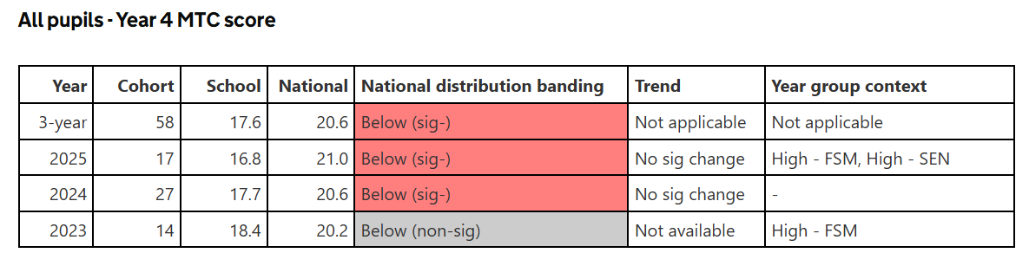

Phonics
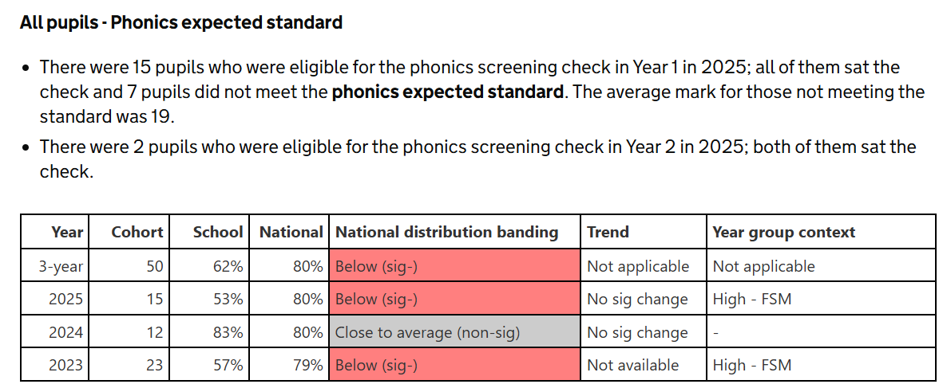

Behaviour, safeguarding & attendance:
Attendance 2025/2026
PP –92.4%
NPP –95.6%

Attendance -in line with national average for FSM/SEND.
Whole School: 93.7% National Average – 94.69%
FSM: National Average – 92.3% School Data: 92.2%
SEND: National Average 92.4% School Data: 92.6%
Whilst the below figures from the IDSR show close to average, we will continue to have a high focus on attendance and persistent absence as this can fluctuate as shown this year.
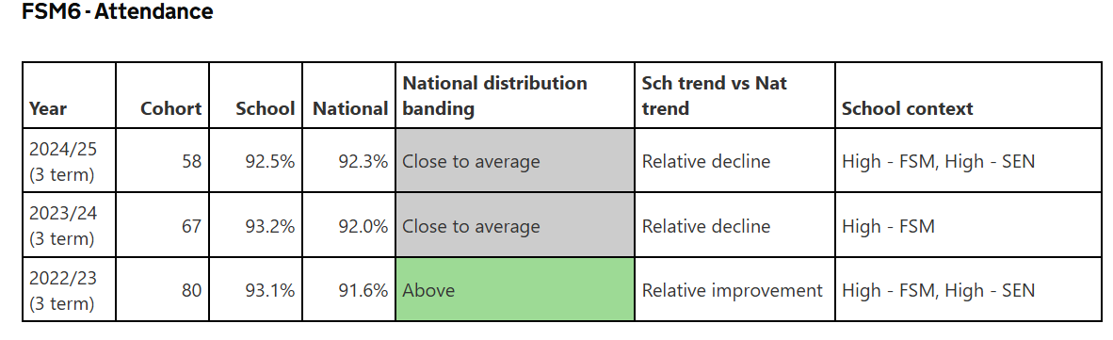
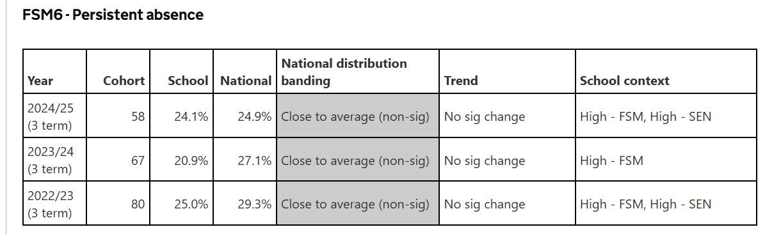
Persistent Absence

Externally provided programmes
Please include the names of any non-DfE programmes that you purchased in the previous academic year. This will help the Department for Education identify which ones are popular in England
Programme | Provider
Phonics Scheme | Read, Write Inc (Ruth Miskin)
Music Scheme | Charanga
French Scheme | Language Angels
PSHCE Scheme | Jigsaw
Computing Scheme | Purple Mash
B Squared | Connecting Steps
Ready, Steady Spell (Spelling) | Literacy Counts
Ready, Steady Write | Literacy Counts
Maths No Problem | Maths No Problem

