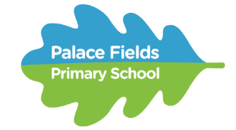
Science Knowledge Organiser

Rocks

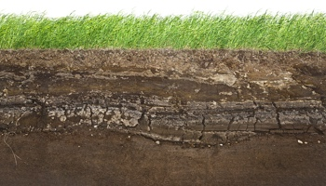
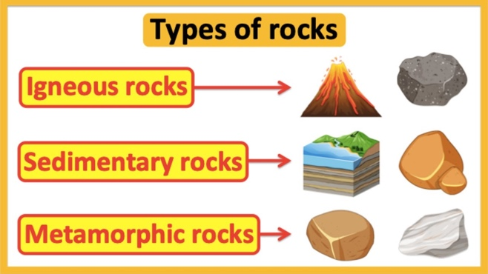

Scientific Enquiry Types:

- Pattern seeking
- Research

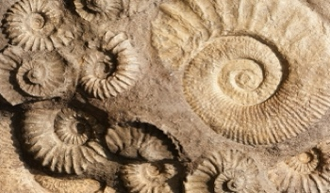

Sticky Knowledge

- Rock is a naturally occurring material.
- Natural rocks can be classified as igneous, metamorphic and sedimentary.
- Igneous rocks are formed from lava or magma.
- Sedimentary rocks are formed from layers of sediment compressed.
- Metamorphic rocks start out as igneous or sedimentary but change due to being exposed to extreme heat or pressure.
- There are different types of rock e.g. sandstone, limestone, slate etc. which have different properties.
- Rocks can be hard or soft.
- They have different sizes of grain or crystal.
- They may absorb water.
- Rocks can be different shapes and sizes (stones, pebbles, boulders).
- Soils are made up of pieces of ground down rock which may be mixed with plant and animal material (organic matter).
- The type of rock, size of rock pieces and the amount of organic matter affect the property of the soil. Some rocks contain fossils.
- Fossils were formed millions of years ago. When plants and animals died, they fell to the seabed. They became covered and squashed by other material. Over time the dissolving animal and plant matter is replaced by minerals from the water.

Vocabulary

- Igneous– rocks formed when molten rock solidifies.
- Metamorphic– rocks created when extreme heat or pressure changes another type of rock.
- Sedimentary– types of rock created through many layers of soil, sand and sediment.
- Grain– a very small piece of something.
- Crystals– a solid material that has a highly organised structure.
- Porous– can soak up liquid or let liquid pass through.
- Fossil– the remains or impression of a prehistoric organism.
- Density- how compact or concentrated something is.
- Durability- how long an object lasts for.
- Porosity- allows water to pass through.

